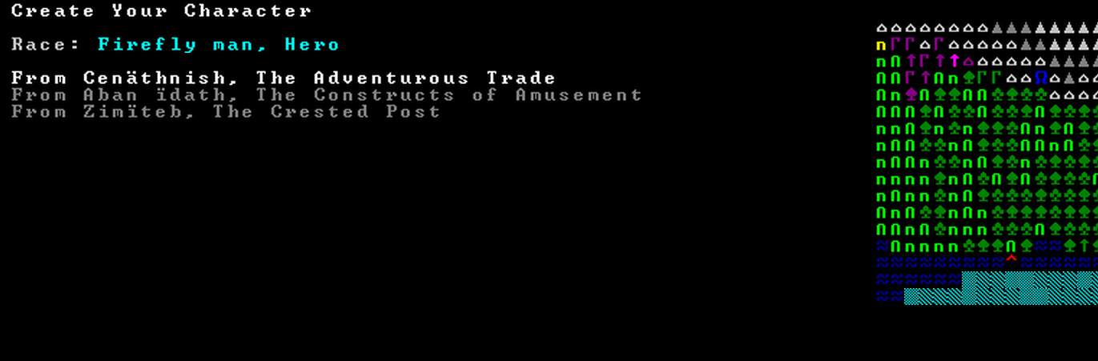

**We’re starting from this fortress (1 of 3) because it’s closest to the dark fortress in the top left “Renownedlie” where there are many prisoners that we want to free.**

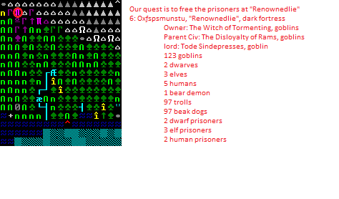



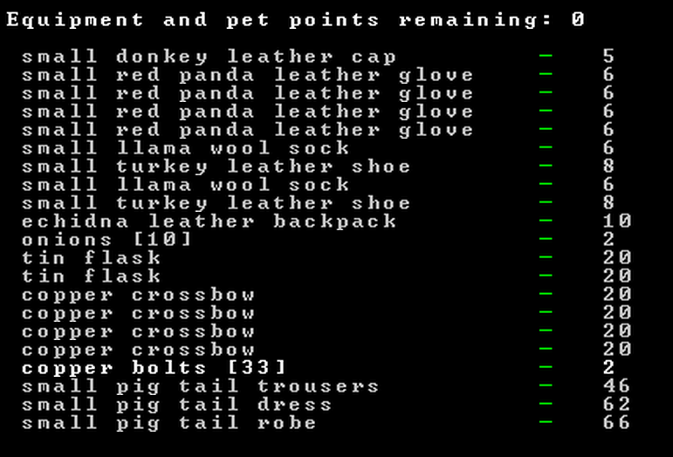

**Kimberly Completed our first camp to be used by adventures on this mission!**

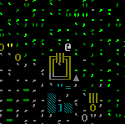

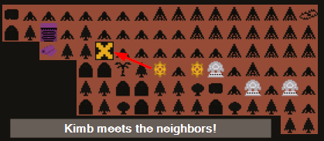

**-----------------------------------------------------------------------------------------------------------------------------**

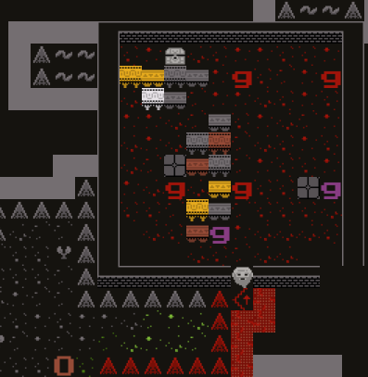

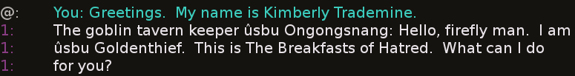

**They didn’t take it very well.  
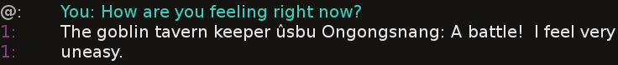**

**Kimb tries to ease the tension by shouting a compliment to the room!**



**Kimb buzzes off to a nearby tower filled with Gobbos and befriends a Goblin Spearman by gifting a lettuce leaf!**

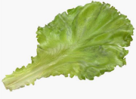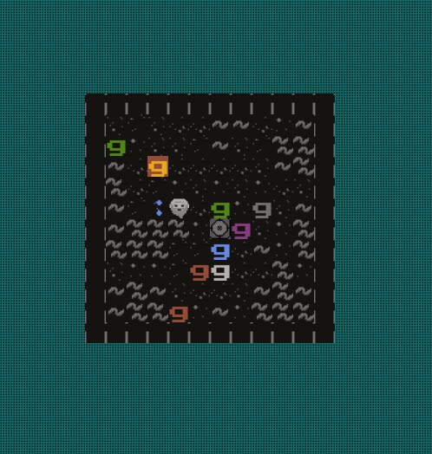

**The Goblin Spearman “Ngokang” yields some potentially useful information.**

**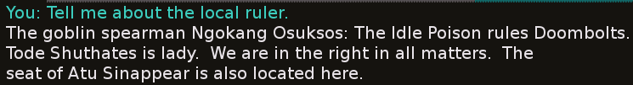  
Kimb investigates the nearby Dark Tower!  
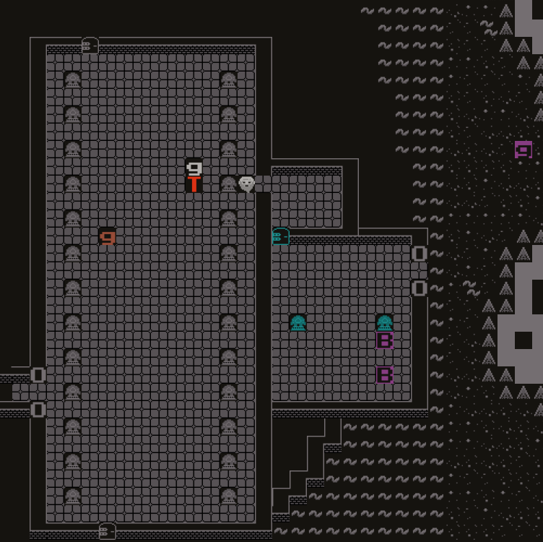**

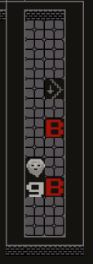

**Kimb sees a Goblin and two Beakdogs and gifts the Goblin a lettuce leaf!**



**Kimb asks Bosa to guide her back to (her very own camp) CrescentBraids, and Bosa the Goblin is ecstatic to help!**

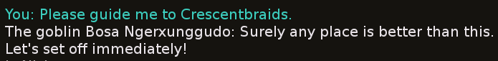

**Bosa wears a Troll fur robe like Mackelmore.**

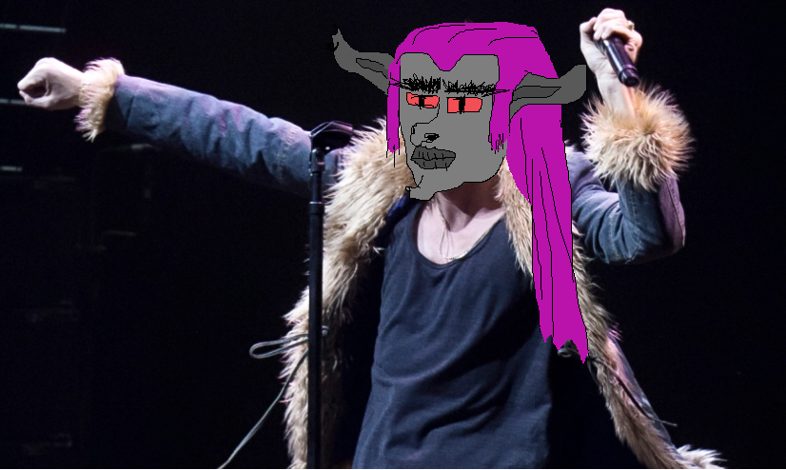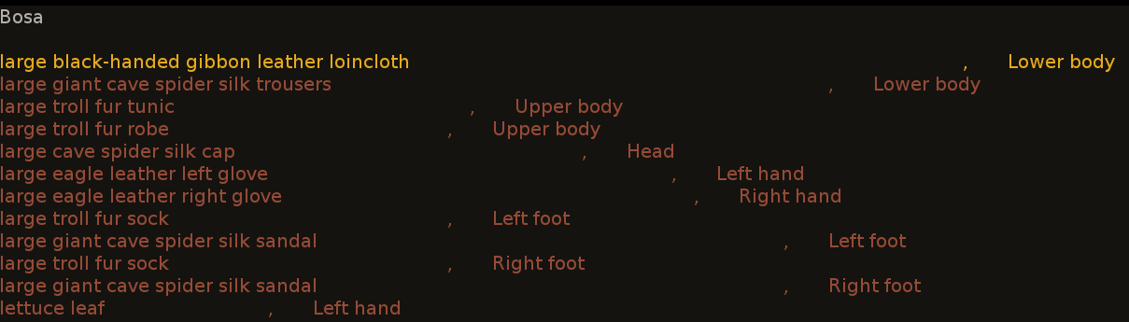

**As Kimb walks to the stairwell to leave, Bosa says goodbye to Beakdoggos.**

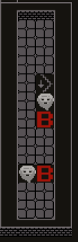



**Bosa decides to attack a Troll outside the Goblin Fortress,  
but he sees reason when Kimb convinces him to calm down.**

**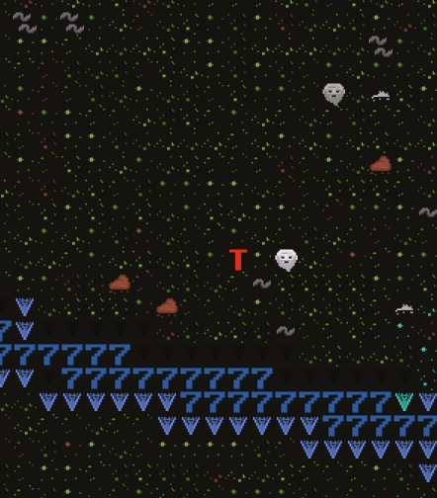   
**

**After leaving the fortress, due South, Kimb is ambushed!  
  
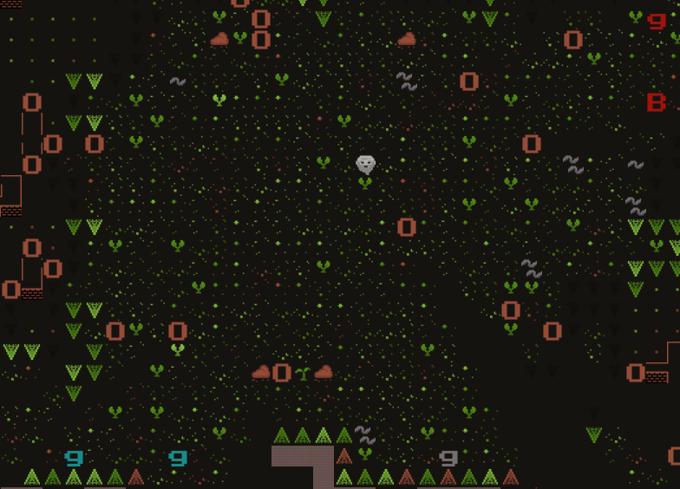**

**Luckily Kimb can fly,  
so she bolted straight up into the air  
while declaring something positive about the experience.  
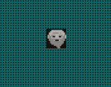  
**

**By the time Kimb made it back to CrescentBraids, she had no companions ☹**

**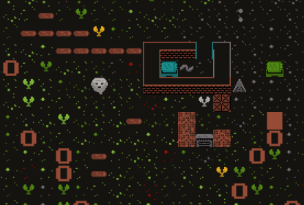  
**

**The camp is small, hard to find.  
  
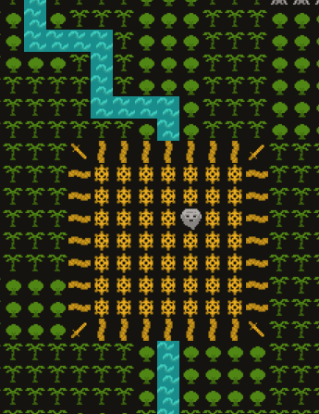**

**Safely back in her dirty hovel, Kimb rejoices!**